Chapter- 1

Introduction

* 1. **PROBLEM STATEMENT :**

To design an android and web application for verification of documents of loan process.

Document verification for any type of loan from CA[Chartered Accountant] as well as Investigator is very lengthy process and is done manually. In proposed system we will try to make verification process easy. Customer applies for loan to bank, bank sends to respective CA for verification of the documents as well as customers identity. CA sends particular loan application to branch investigator for investigation. For mortgage purpose the investigator investigates essential documents of the customer. In next step investigator uploads an investigated documents in banks database for approval. The documents uploaded through app and saved on the banks database can be approved by CA as well. After all this investigation and verification the application of customer for particular loan will be approved.

With this web based automated system, accuracy as well as efficiency will increase

* 1. **INTRODUCTION :**

Getting a loan is a very exhausting and complicated process in India. It may take weeks even months for loans to get approved by bank.Proposed project automates the verification of loan document process.

In every bank the process of document verification for loan is carried out manually, instead of this, toimprove the process aweb and android based application can be useful.

Verification process begins with customer application for any type of loan to a Bank, the Bank accepts the request and forwards loan request to respective CA for documents checking. Then the modified documents will be uploaded through android app or web application and will be stored in database.

Chapter- 2

Literature Review

Numerous studies have been done that have focused on banking loan system, document verification. They have applied different online loan procedure for customer.Following are the some paper that we have studied.

TC Shan…[7] describes an e-Business solution model designed in Wachovia Corporation, one of the top banks in USA, serving millions of customers with a variety of financial services such as online banking, bill pay and brokerage.

Tzhou ,& S Zhang,& B JI [10]– This research proposed that online banking service quality, reputation and security influence users’ continuance usage through trust and satisfaction.

Z Karim and K M Rezaul[5]& A Hossain This paper investigated the current debate regarding the threats and vulnerabilities of the information security.

D Sciglinpaglia[6], D Ely, This study suggested that institutions are vulnerable to loss of customers to rivals with extensive online services.

B. Sriram and R. Prashant Iyer[11] - This paper was worked on a student project for implementing a document authenticator;all important parameters in a mark sheet are encrypted into sa 2D barcode. When verifying, the 2D barcode is decoded and decrypted; the original data is displayedby the application’s graphical user interface.

Chapter- 3

Methodology

**3.1 ALGORITHM**

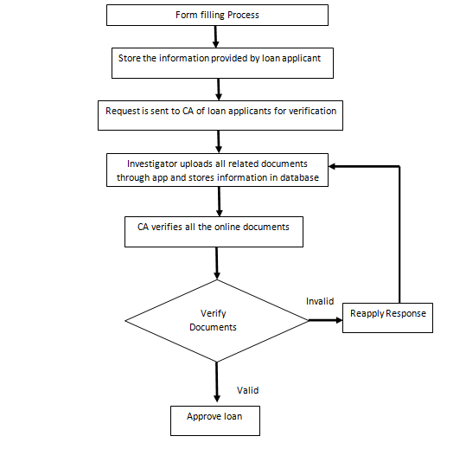

**3.2HARDWARE AND SOFTWARE REQUIREMENTS**

**3.2.1 Software Required**:

* Windows Xp, Windows 7,Windows 8
* MySql
* PHP
* Android

**3.2.2 Hardware Required**:

* Processor – Dual Core
* Hard Disk – 80 GB
* Memory – 1GB RAM
  1. **Technology Used**

**3.1 PHP:-PHP** is a server-side scripting language designed primarily for web development but also used as a general-purpose programming language.PHP code may be embedded into HTML code, or it can be used in combination with various web template systems, web content management systems and web frameworks. PHP code is usually processed by a PHP interpreter implemented as a module in the web server or as a Common Gateway Interface (CGI) executable.

**3.2 Android:-Android** is a mobile operating system developed by Google, based on the Linux kernel and designed primarily for touchscreen mobile devices such as smartphone and tablets. Android's user interface is mainly based on direct manipulation using touch gestures. Android provides the ability to run applications that change the default launcher, and hence the appearance and externally visible behaviour of Android. These appearance changes include a multi-page dock or no dock, and many more changes to fundamental features of the user interface.[

**3.3 MySQL:-** is an open-source relational database management system (RDBMS).

**Structured Query Language**. **SQL** is used to communicate with a database.Is a special-purpose **programming** language designed for managing data held in a relational database management system (RDBMS), or for stream processing in a relational data stream management system (RDSMS).

Chapter- 4

Design and Implementation

In the UML diagrams it describes the structure of the system where it shows the working of the project .UML diagrams includes different figures as shown below. Wherein each figure the working of the project is explained. It includes from initial state to exit state.

Initially user login into the page,where the user can check the status of the devices whether it is ON or OFF. The next step involves changes in the devices such as ON or OFF.

1. Class Diagram

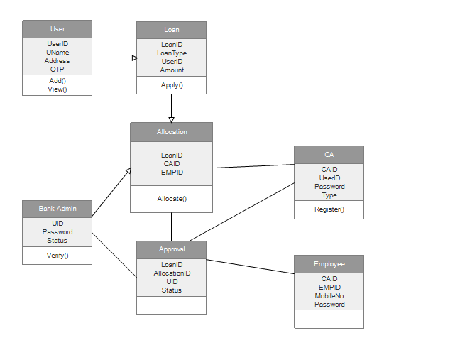

1. Use Case Diagram

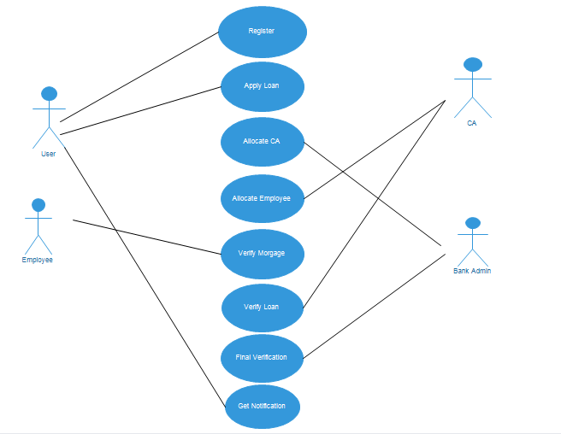

1. Sequence Diagram

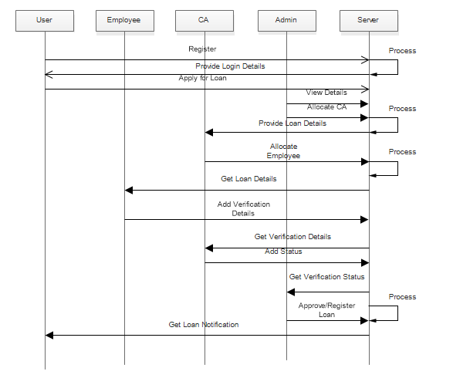

1. Data Flow Diagram

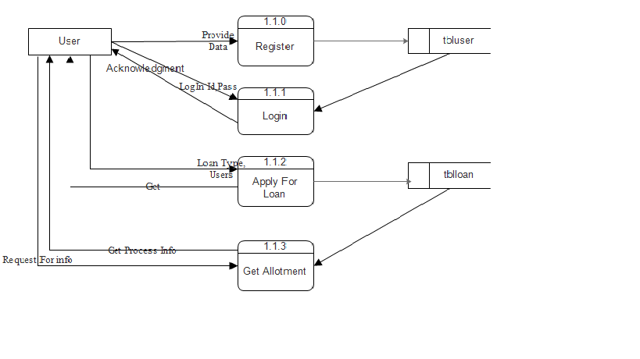

Fig. First Level DFD

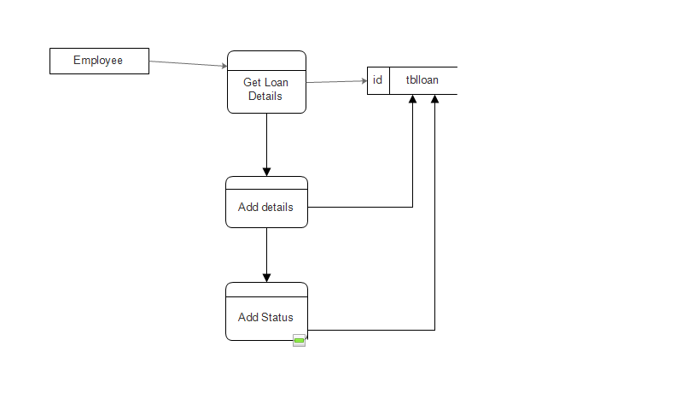

Fig. Employee Side DFD

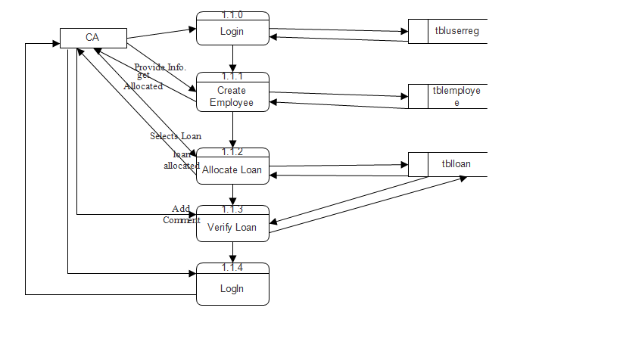

Fig. CA Side DFD

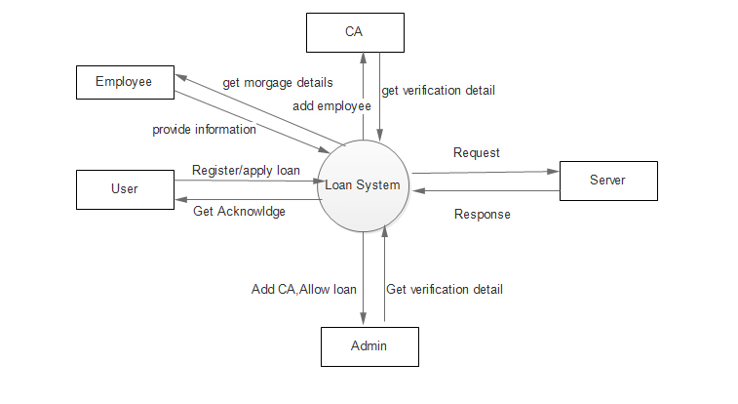

Fig. Context Level DFD

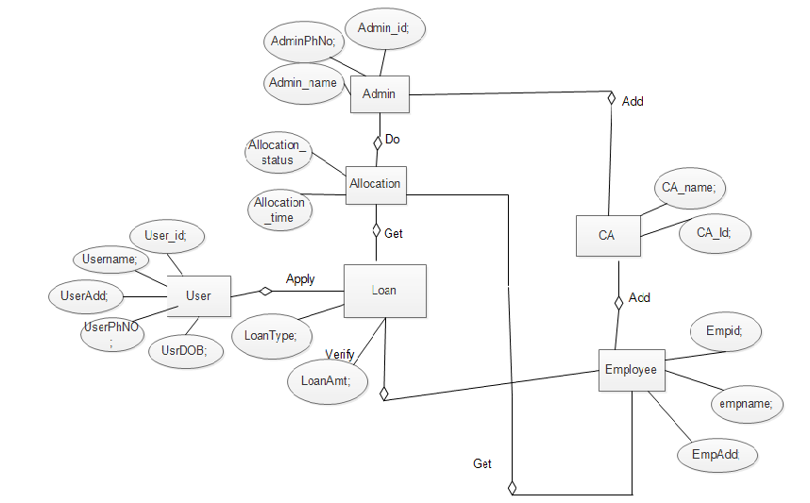

Fig. ER Diagram

Chapter- 5

Testing

**5.1 Software Testing Strategy**

A test strategy is an outline that describes the testing approach of the [software development cycle](http://en.wikipedia.org/wiki/Software_development_process). It is created to inform project managers, testers, and developers about some key issues of the testing process. This includes the testing objective, methods of testing new functions, total time and resources required for the project, and the testing environment. Test strategies describe how the product risks of the stakeholders are mitigated at the test-level, which types of test are to be performed, and which entry and exit criteria apply. They are created based on development design documents. System design documents are primarily used and occasionally, conceptual design documents may be referred to. Design documents describe the functionality of the software to be enabled in the upcoming release.

Chapter-6

Screenshots

1. Home Page

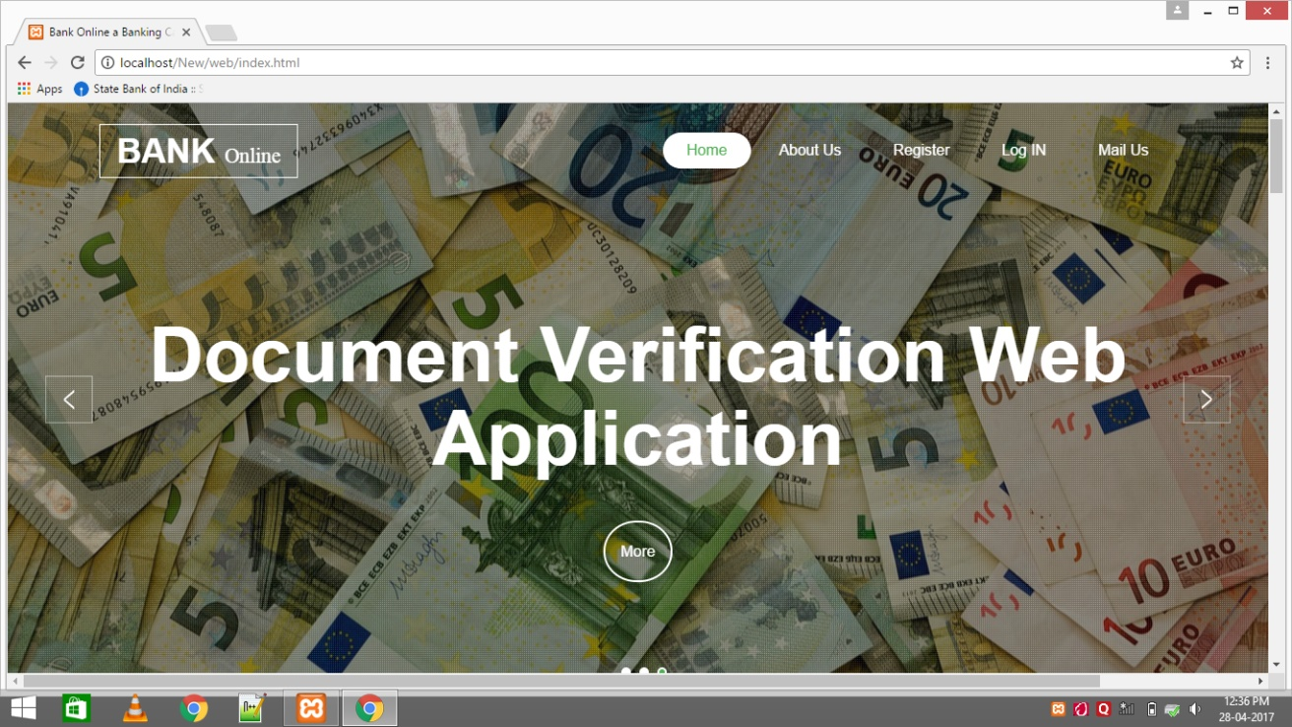

1. Login Page

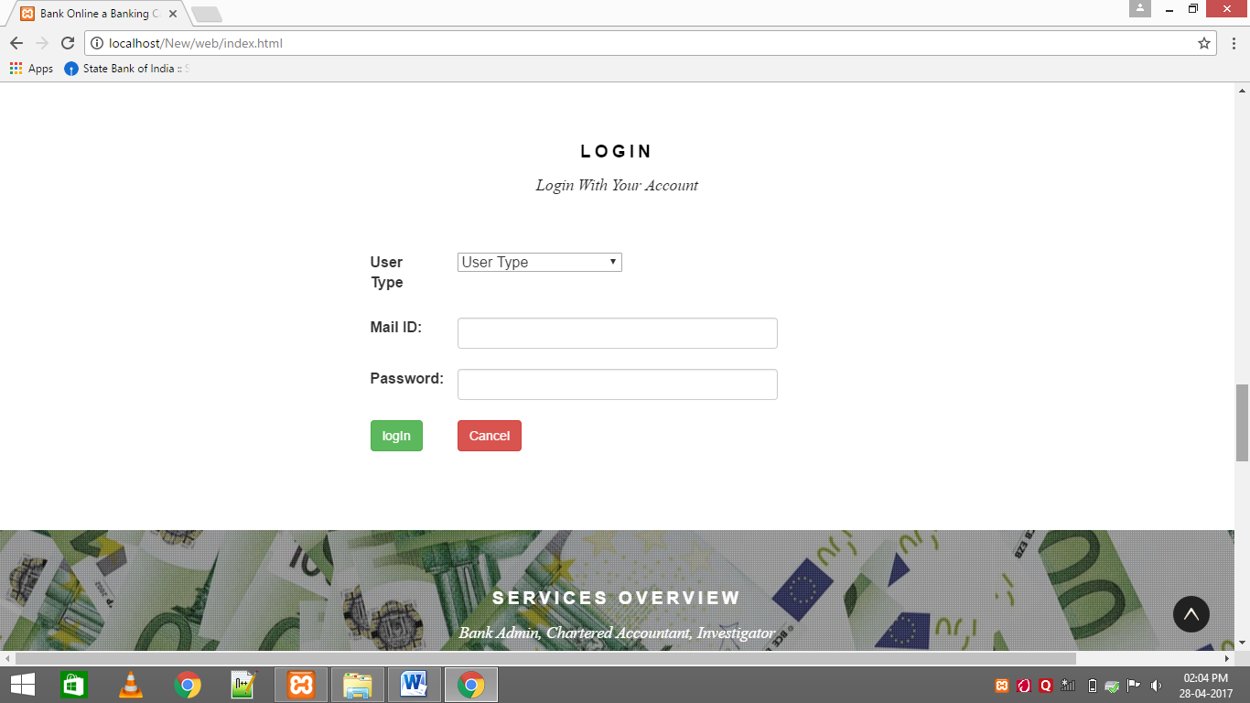

1. Home Loan

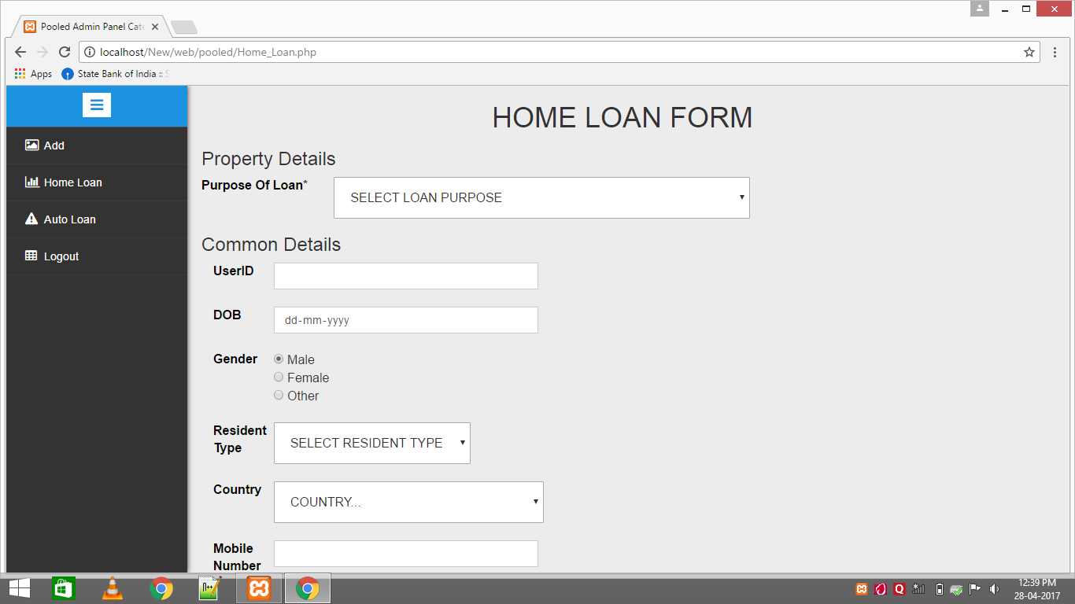

4.CA List

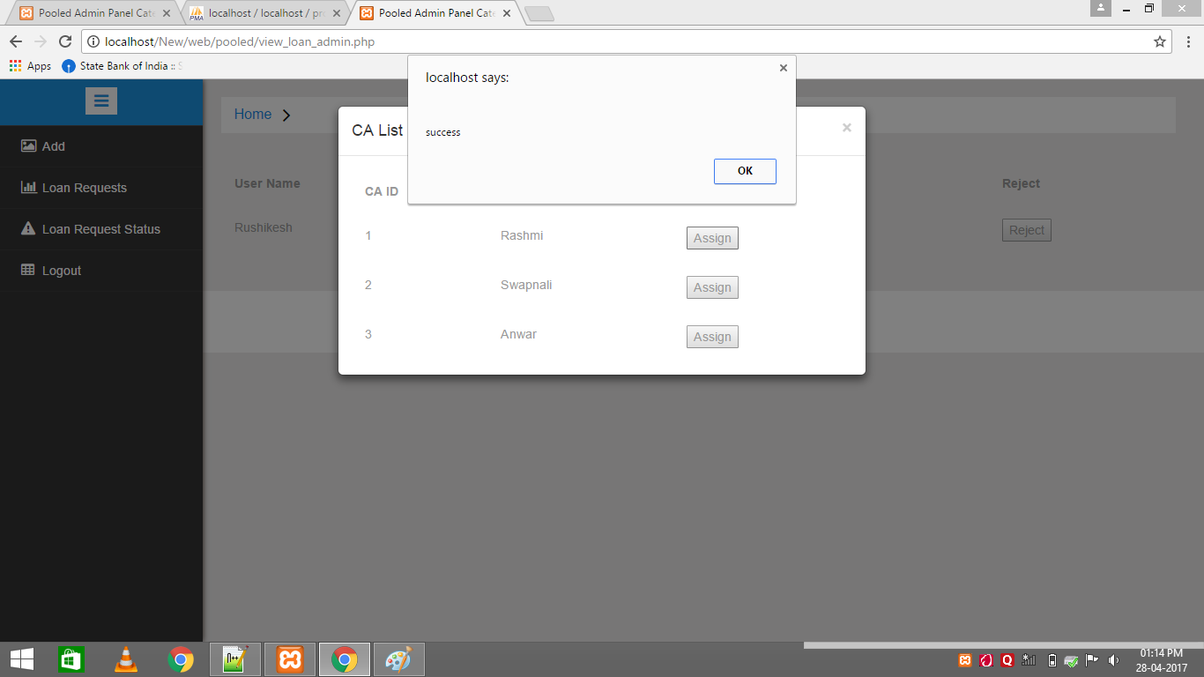

5 .Applicant Details

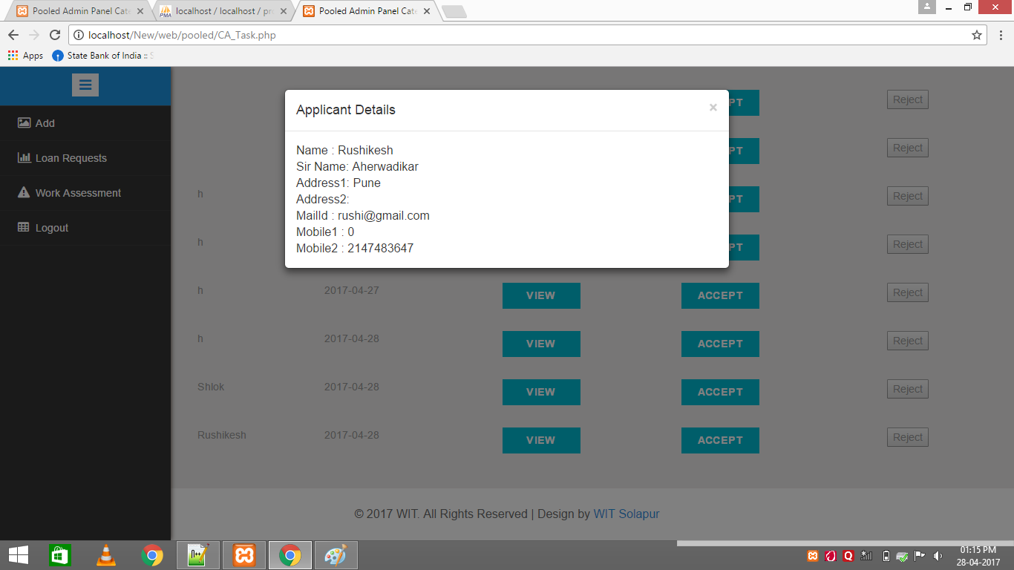

6 .List of applicants to send at Investigator

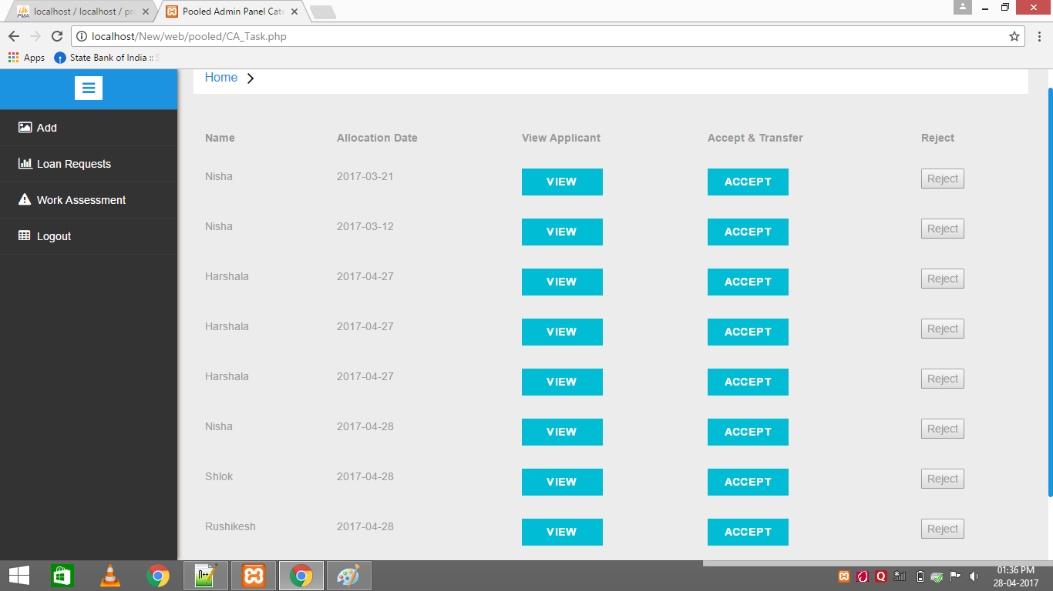

7.Investigator Login:

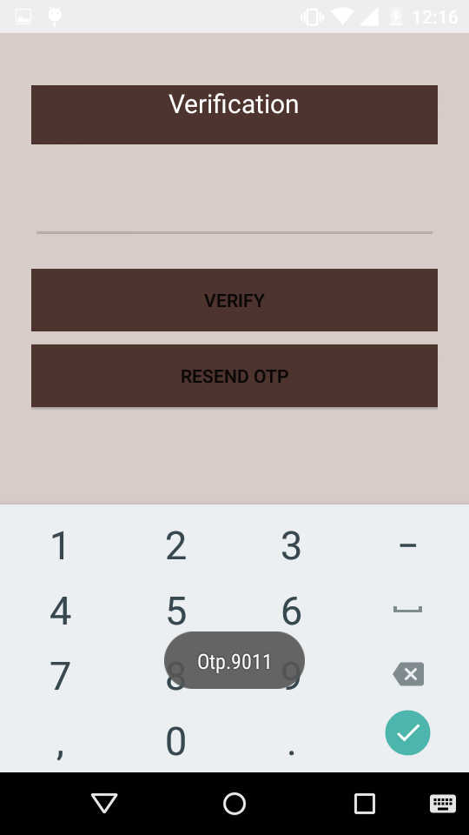

8. Notification:

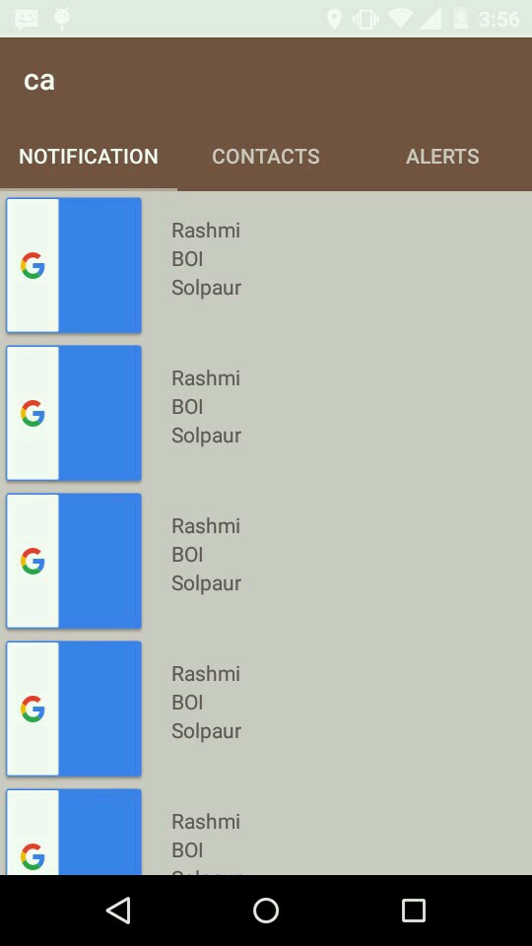

9. Document Upload:

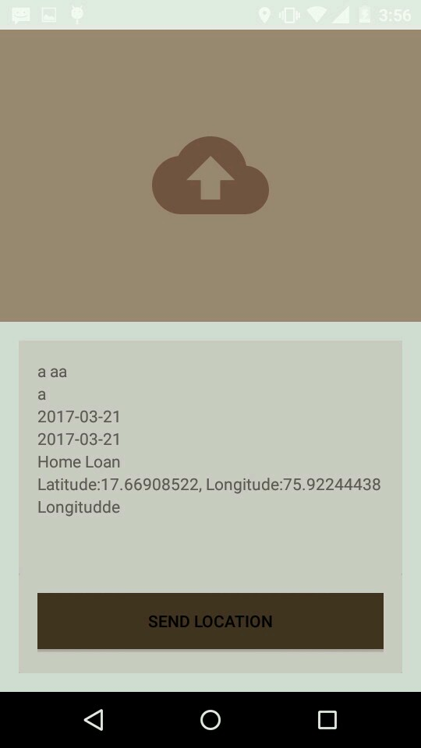

Chapter- 7

Conclusion

**Conclusion:**It provides a very easy and timesaving process for the CA as well as banking staff to record the entire loan related customer details and to give proper information.

Chapter- 8

References

[1]L.Lamport, “Investigation of Bank Loan Process”,Vol.24No.11,PP,770-772,1981.

[2] Z Liu,Q Min, S JI “An imperial study on mobile banking adoption: the role of trust”,commerce and security,2009. ISECS ’09,2009.

[3] KY Tam,M kiang – “Predicting bank failures: a neural network approach”- Applied Artificial Intelligence an international, 1990- Taylor And Francis.

[4] MR Aburrous , A Hossain,F Thabatah- “Intelligent quality performance assessment for E-banking security using fuzzylogic”, ITNG, 2008.

[5] Z Karim, KM Rezaul, A Hossain-“Towards secure information systems in online banking ”- Internet technology, 2009.

[6] D Sciglinpaglia, D Ely-“Internet banking: A customer centric perspective ”, 2002, HICSS, 2002.

[7] TC Shan…-“Building a service-oriented e-Banking platform”, 2004(SCC 2004).

[8] SM Dewan- “Issues in M-Banking: Challenges and opportunities”-Information Technology(ICCIT)2010.

[9]MM Mashhadi, M Tofighi-“Investigating Customers Decision To accept E-Banking Services”,2007 ,IEEE International 2007.

[10]Tzhou, S Zhang, B JI –“Exploring the effect of online banking service quality on users continuance usage”,Second International Conference 2010.

[11]B. Sriram and R. Prashant Iyer “ Mark SheetAuthentication Using 2D Barcodes And Digital Signature”, IEEE International, 2009.